Mathematics
BECE 2022 — Paper 1 (Objective)
1. Write 1930.54 in standard form.
A. 1.93054 × 10².
B. 1.93054 × 10³.
C. 1.93054 × 10⁻².
D. 1.93054 × 10⁻³.
2. For what value of x is 3ˣ = 81?
A. 2.
B. 4.
C. 27.
D. 9.
3. A car travels 36 kilometres in an hour. Find its speed in metres per second.
A. 10 m s⁻¹.
B. 100 m s⁻¹.
C. 20 m s⁻¹.
D. 200 m s⁻¹.
4. If n/100 = 10.5, find the value of n.
A. 1050.
B. 0.105.
C. 105.
D. 0.0105.
5. If a trader made a profit of 10% in selling a shirt for GH¢44.00, find the cost price.
A. GH¢39.60.
B. GH¢38.50.
C. GH¢48.40.
D. GH¢40.00.
6. Simplify: 1 1/5 ÷ 2 1/10
A. 4/7.
B. 2 13/25.
C. 12/63.
D. 25/63.
7. The volume of a cylinder is 40π cm³. If the height of the cylinder is 10 cm, find the base radius.
A. 1 cm.
B. 4 cm.
C. 3 cm.
D. 2 cm.
8. The longest chord of a circle is the
A. sector.
B. segment.
C. circumference.
D. diameter.
9. If x = (b² − 4ac)/(2a), find x when a = 2, b = −4 and c = −2.
A. 16.
B. 0.
C. 4.
D. 8.
10. The ratio of farmers to children in a village is 13:11. If there were 312 farmers in the village, how many children were there?
A. 143.
B. 169.
C. 264.
D. 48.
11. Arrange the following fractions from the lowest to the highest: 3/5, 1/4, 2/3.
A. 2/3, 1/4, 3/5.
B. 2/3, 3/5, 1/4.
C. 1/4, 3/5, 2/3.
D. 3/5, 1/4, 2/3.
12. What is the length of the side of a square of area 225 cm²?
A. 15.00 cm.
B. 56.25 cm.
C. 12.00 cm.
D. 112.50 cm.
13. The rule of a mapping is 2x² − 1. What number does x = 2 map to?
A. 3.
B. 9.
C. 7.
D. 8.
14. Express 108 as a product of prime factors.
A. 2³ × 3.
B. 2 × 3⁴.
C. 2³ × 3².
D. 2² × 3³.
15. Express 15:12 in the form 1 : n.
A. 1 : 12.
B. 1 : 15.
C. 1 : 1.2.
D. 1 : 0.8.
16. Given that P(3, −2) and Q(−2, 4) are points in a plane, find the gradient of the line joining P to Q.
A. 5/6.
B. −5/6.
C. −6/5.
D. 6/5.
17. A shop is rented at GH¢9.00 per month. How much money is paid in 1½ years?
A. GH¢162.00.
B. GH¢13.50.
C. GH¢135.00.
D. GH¢6.00.
18. In the diagram, AB is parallel to DE, angle ABC = 81° and angle DCE = 20°. (Use the information to answer Questions 18 and 19.) What is the value of x?
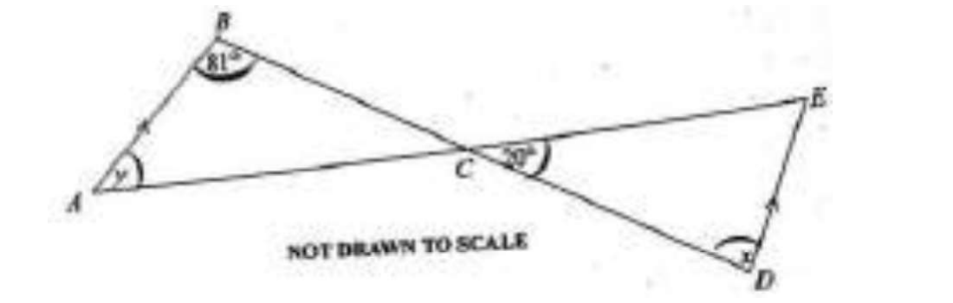
A. 20°.
B. 101°.
C. 81°.
D. 61°.
19. Find the value of y (using the diagram in Question 18).
A. 101°.
B. 20°.
C. 79°.
D. 81°.
20. What is the probability that a number greater than 5 shows up when a die is thrown?
A. 1/6.
B. 1/3.
C. 5/6.
D. 2/3.
21. A mother has GH¢5.00 and gives each of her 3 children GH¢1.50 as pocket money. How much is left for her?
A. GH¢4.50.
B. GH¢0.50.
C. GH¢0.15.
D. GH¢3.50.
22. Expand: (2a − b)(a − b).
A. 2a² − 3ab − b².
B. 2a² + 3ab + b.
C. 2a² − 3ab + b².
D. 2a² + 3ab − b.
23. Peter had GH¢200.00 and spent GH¢83.00. What percentage of the money is left?
A. 29.06%.
B. 70.94%.
C. 41.50%.
D. 58.50%.
24. The stem and leaf plot below shows the weight (kg) of cocoa bags weighed in a week:
Stem | Leaf
4 | 0, 5, 7, 9
5 | 1, 3, 4, 5, 7, 8
6 | 0, 2, 3, 4, 4, 4, 4, 5, 6, 8
7 | 1, 2, 3, 4, 5, 8, 8, 9
8 | 2, 3, 5, 6, 9
9 | 4, 5
(Use the information to answer Questions 24 to 26.) What is the modal weight of the bags of cocoa?
A. 60 kg.
B. 68 kg.
C. 65 kg.
D. 64 kg.
25. What is the median weight of the bags of cocoa (using the stem and leaf plot in Question 24)?
A. 65 kg.
B. 62 kg.
C. 61 kg.
D. 68 kg.
26. How many bags of cocoa were weighed in the week (using the stem and leaf plot in Question 24)?
A. 41.
B. 35.
C. 29.
D. 6.
27. Simplify: −15 − (−20) + (−10).
A. −45.
B. −25.
C. −5.
D. 5.
28. Given that vector PQ (column vector) = (−3, 8), find vector QP.
A. (−3, 8).
B. (−3, −8).
C. (8, −3).
D. (3, −8).
29. Which of the following is not a quadrilateral?
A. Parallelogram.
B. Rhombus.
C. Triangle.
D. Rectangle.
30. Express 3/8 as a decimal fraction.
A. 0.429.
B. 0.375.
C. 0.625.
D. 0.365.
31. Factorize completely xy − xm − my + m²
A. (y − m)(m − x).
B. (m − y)(m − x).
C. (x − m)(y − m).
D. (m − y)(x − m).
32. Adwoa travelled 12 km due north and 5 km due east. How far was she from her starting point?
A. 13 km.
B. 7 km.
C. 17 km.
D. 60 km.
33. A certain number is subtracted from 12 and the result is multiplied by 3. If the answer is 21, find the number.
A. 4.
B. 8.
C. 6.
D. 5.
34. A football match starts at 2:20 p.m. and lasts for 1 hour 50 minutes. At what time will the game end?
A. 3:10 pm.
B. 5:10 pm.
C. 4:10 pm.
D. 6:10 pm.
35. Given that 117(12+18) = 117(15+k), find the value of k.
A. −30.
B. 30.
C. 15.
D. −15.
36. If a = (2, −3) and b = (−2, 3) are column vectors, find a + b.
A. (4, 0).
B. (2, 3).
C. (0, 0).
D. (0, 6).
37. Solve: (x − 1) = 1/2(x + 2).
A. 1 1/3.
B. 0.
C. 1 1/2.
D. 4.
38. The point S(4, 3) is reflected in the y-axis. Find the coordinates of the image of S.
A. (−3, 4).
B. (3, −4).
C. (−4, 3).
D. (4, −3).
39. Solve: 5x − (7x − 3) ≤ 9.
A. x ≥ −3.
B. x ≤ 3.
C. x ≥ −6.
D. x ≤ −3.
40. Which of the following is the largest set?
A. {Natural numbers}.
B. {Composite}.
C. {Integers}.
D. {Whole numbers}.

Answer Key
1. B 1.93054 × 10³.  2. B 4.  3. A 10 m s⁻¹.  4. A 1050.  5. D GH¢40.00.  6. A 4/7.  7. D 2 cm.  8. D diameter.  9. D 8.  10. C 264.  11. C 1/4, 3/5, 2/3.  12. A 15.00 cm.  13. C 7.  14. D 2² × 3³.  15. D 1 : 0.8.  16. C −6/5.  17. A GH¢162.00.  18. C 81°.  19. C 79°.  20. A 1/6. | 21. B GH¢0.50.  22. C 2a² − 3ab + b².  23. D 58.50%.  24. D 64 kg.  25. A 65 kg.  26. B 35.  27. C −5.  28. D (3, −8).  29. C Triangle.  30. B 0.375.  31. C (x − m)(y − m).  32. A 13 km.  33. D 5.  34. C 4:10 pm.  35. C 15.  36. C (0, 0).  37. D 4.  38. C (−4, 3).  39. A x ≥ −3.  40. C {Integers}.

